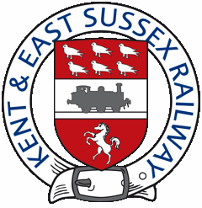
Press Release
10 August 2021

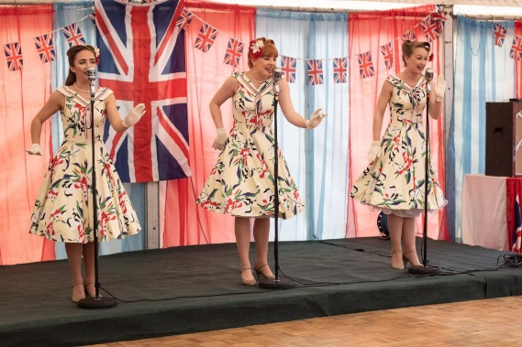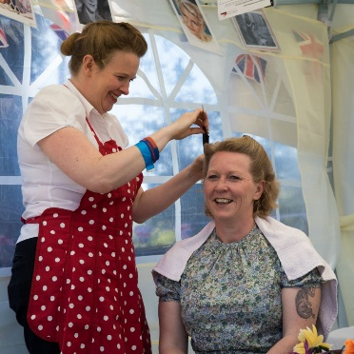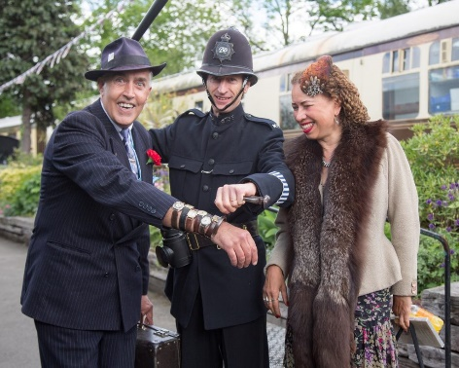

Fabulous 40 weekend at the Kent & East Sussex Railway,

Saturday 11th and Sunday 12th September 2021

This September will see the return of the sights, sounds and fashions of the 1940s, recreated along the line at the Kent & East Sussex Railway.

Passengers will take a nostalgic step back in time to experience the 40s lifestyle as the railway turns back the clock to wartime Britain. Steam Trains will be leaving Tenterden and Bodiam stations hourly between 10:30 and 4:30 on each day and with Freedom tickets, passengers can enjoy unlimited train travel during the day of their visit. Passengers are encouraged to join in the fun and dress in the fashions popular during the war.
Entertainment will include live music at Tenterden and Bodiam from popular group ‘My Favourite Things’, Miss Holiday Swing and the Ruby Sisterz. The Cinque Ports Lindy Hoppers will perform their energetic dancing at Tenterden. There will be a vintage pop up tea room at Bodiam and Ministry of Food Cooking Demonstrations at Tenterden, plus you may even catch sight of a Spitfire!
Vintage stalls, costumed re-enactors, live performers, period civilian and military vehicles will all create the atmosphere of the period. Belles Parlour will be taking appointments during the weekend for her popular 1940s Hairstyling salon and notorious ‘Viv the Spiv’ will return with his black market goods. Among the re-enactors will be the Fire Service Preservation Group, Blackout Buddies and following their debut at the 2019 event, the 1940s Corner Shop.
Interactive land army displays and activities can be enjoyed at Bodiam station. Explore the Desert Rats encampment display filled with authentic kit, weapons and a variety of jeeps and civilian vehicles plus the Royal Navy Beach Commando unit.

Sales & Marketing Manager for the Railway, Helen Douglas said “We are delighted to see the return of our popular wartime event. After such a long period apart, we are looking forward to the return of this popular weekend which creates such energy across the railway! With so much to engage the young and young at heart and trains throughout the day, there will be fun for all the family.”

Prices for tickets to the event including the Freedom of the Line when booked online in advance are £56.50 for a family of 4. £24.50 for an Adult and £13.50 for Children aged 3-15.

Bookings can be made via the railway’s website https://kesr.org.uk/1940s-weekend/

Bodiam Castle is a short walk from Bodiam Station. Presenting a valid train ticket entitles passengers to discounted entry to Bodiam Castle.

* Flying display subject to weather conditions

Every effort will be made to provide the attractions as advertised; but unforeseen circumstances may result in alteration or cancellation at short notice.

Prices for tickets purchased on the day will not be subject to the online discounts.

Notes for editors
The Kent & East Sussex Railway, was the first light railway opened in Britain under the Light Railways Act of 1896, built by Holman F. Stephens.
Today it is one of Britain’s most loved and original heritage railways, running for over 10 miles from Tenterden, capital of the Kentish Weald, to Bodiam in Sussex in the shadow of the 600 year old National Trust castle.

The Kent & East Sussex Railway is operated by the Kent & East Sussex Railway Co Ltd, a charitable company, limited by guarantee and not having a share capital. Registered charity No. 262481.

Tenterden Town Station, Station Road, Tenterden, Kent TN30 6HE

Press enquiries to Helen Douglas at Kent & East Sussex Railway email hdouglas@kesr.org.uk / 07376 947347

