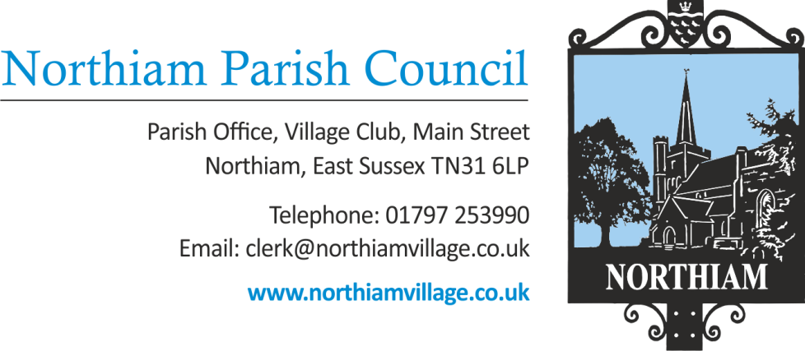

Meeting of the SFF Committee to be held in the Jenkins Room, Northiam
at 5.30pm, Thursday 30th June 2022

Members of the Public and Press are welcome and encouraged to attend.
There will be an opportunity for questions from members of the public.

DRAFT AGENDA

Signed: Nicola Ideson, Parish Clerk Date: 30th June 2022

ATTENDEES:

-------------------------------------------------------------------------------------------------------------------------------

- APOLOGIES FOR ABSENCE: TONY BIGGS; SARAH GILES
- PUBLIC QUESTIONS (Maximum of 15 minutes)
- APPROVAL OF MINUTES FROM SFF COMMITTEE MEETING ON 23.5.22
- UTILITY CHARGES – AN UPDATE FROM CIC ON SEWAGE CHARGES AND NPC ON RECOVERIES FROM STABLE’S TENANT
- STABLES
6.1 GH’S ADDITIONAL FEE FOR AMENDING THE NEW LEASE
6.2 PLANNING AND HIGWAYS
6.3 SECURITY AND CCTV PROVISION
6.4 STRORM INSURANCE CLAIM
6.5 PREMIUM RECOVERY FROM STABLE’S TENANT
- TO REPORT CIC’S PROPOSALS FOR HAY AND GRAZING

- TO REPORT ON GREATER CRESTED NEWT POND FOLLOWING MEETING 28th JUNE at 14.00

- DISCUSSION ON SITE BOUNDARY INCURSIONS

- FUTURE CONTRACTUAL RELATIONSHIP BETWEEN NPC AND CIC
- UPDATE – NPC’S PROVISION OF SHEDS FOR BUNGALOWS
- BURIAL GROUND

12) CIC’S PROPOSED IMPROVEMENTS TO HUB
12.1 W/Cs
12.2 TEMPORARY PROVISION OF CANOPY OVER HUB YARD
13) TO REPORT INVITATION FROM ESCC FOR SFF CIC TO ATTEND RECEPTION ON 9th JULY 2022

14) DATE OF NEXT MEETING – 28th JULY 2022

