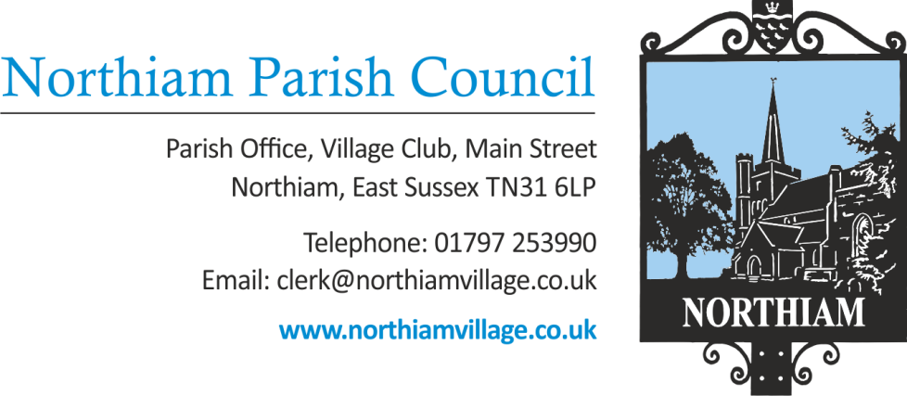

Meeting of the Parish Council to be held in the Village Hall, Northiam at 7.00pm, Thursday 8th September 2022

Members of the Public and Press are welcome and encouraged to attend.
Due to the adoption of new Standing Orders there will be an opportunity for members of the public to give their opinion or view once in relation to an item on the agenda.
AGENDA

SIGNED: Nicola Ideson, Parish Clerk Date: 2nd Sept 2022
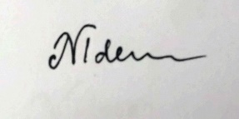
-------------------------------------------------------------------------------------------------------------------------------

- APOLOGIES FOR ABSENCE:

- PUBLIC QUESTIONS (Maximum of 15 minutes)

- DECLARATIONS OF INTEREST AND INSTANCES OF LOBBYING
To receive any declaration by members of personal interests in matters on the agenda, the nature of the interest and whether the member regards the interest as personal, pecuniary or prejudicial under the Code of Members Conduct.

An opportunity for Councillors to declare if they have been approached by a member of the public or another Councillor and asked to discuss any items on the agenda prior to the meeting.

- MINUTES OF THE PREVIOUS MEETING
To approve and sign the minutes of the Full Council meeting held on 11th August 2022 (appendix 1)
- MATTERS ARISING FROM THE MINUTES
- INDEPENDENT INSPECTION OF NEW SLIDE
The Clerk has sourced another playground equipment supplier that is willing to give a free expert opinion,

- FINANCES
- To receive & approve the payment report for August 2022 (appendix 4)
- To receive the most recent bank reconciliation and financial report (appendix 5)
- To approve the time-sheet of the Clerk for the period 05/08/22-02/09/22
- To approve the time-sheet of the assistant Clerk for the period 05/06/22-02/09/22

- MEETING WITH GREYMOOR REGARDING THE SEWER DIVERSION AT THE PADDOCK

- VENTILATION SYSTEM FOR BUNGALOW NUMBER 2

- PLAYINGFIELD FENCING REPAIR QUOTES

- REPORTS BY COUNTY & DISTRICT COUNCILLORS
- District Councillor Martin Mooney (Appendix 2)
- District Councillor Tony Ganly
- County Councillor Paul Redstone (Appendix 3)

- VILLAGE MATTERS
- Correspondence
- Councillors’ Reports

- PLANNING:
New Applications/Amendments to current applications:
- RR/2022/1993/P13 Donsmead Drive, Northiam TN31 6EQ
Single storey pitched roof and front porch extension with revised internal layout.

- RR/2022/1881/P & RR/2022/1882/L
Frewen College Frewen Educational Trust Ltd Rye Road Northiam TN31 6NL.
Installation of temporary Portakabin building for period of three years.

- RR/2022/2164/T
Alpine House, 5 Cedar Close, Northiam TN31 6PL.
T1 - Oak: 5m upper crown reduction.

All appeals, enforcements and decision notices have been previously circulated to Councillors.

