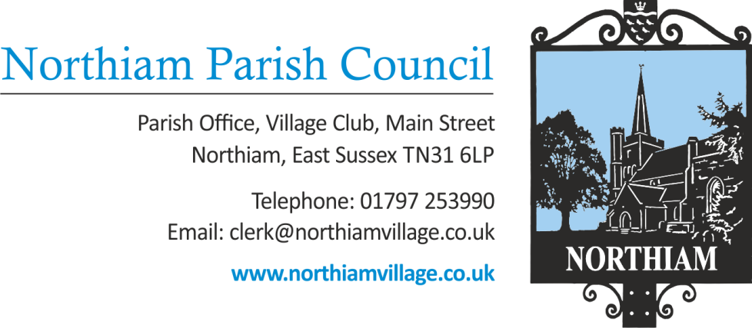

Meeting of the Parish Council to be held in the Village Hall, Northiam at 7.00pm, Tuesday 20th December 2022
Councillors are summoned to attend

Members of the Public and Press are welcome and encouraged to attend.

Extraordinary Council Meeting

AGENDA

SIGNED: Tony Biggs, Vice Chair Date: 12th December 2022

Tony Biggs

-------------------------------------------------------------------------------------------------------------------------------

- APOLOGIES FOR ABSENCE:

- PUBLIC QUESTIONS (Maximum of 15 minutes)

- DECLARATIONS OF INTEREST AND INSTANCES OF LOBBYING
To receive any declaration by members of personal interests in matters on the agenda, the nature of the interest and whether the member regards the interest as personal, pecuniary or prejudicial under the Code of Members Conduct.

An opportunity for Councillors to declare if they have been approached by a member of the public or another Councillor and asked to discuss any items on the agenda prior to the meeting.

- HUMAN RESOURCES
To consider appointing the locum clerk for 5-10 hours per week.

