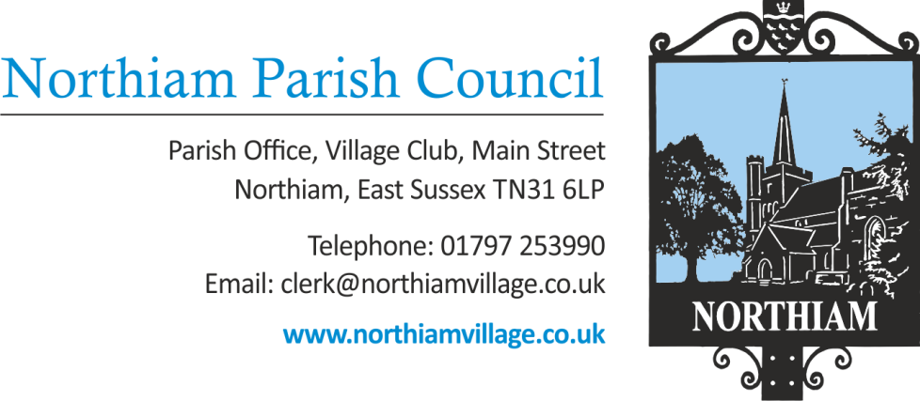

MINUTES

Minutes of the Finance Committee meeting held on Tuesday 2nd January 2024 at 17.30.

Present: Cllr Sargent (Chairman) Cllrs Fairbrass, Harding, Schlesinger and Wadie.

Also Present: Nicola Ideson, Parish Clerk Date: 2nd January 2024
-------------------------------------------------------------------------------------------------------------------------------

- Apologies for Absence
None received.

To adjourn the meeting to enable members of the public and Councillors to address the meeting.
This is a concessionary short session and will be limited to 15 minutes. Three minutes per person will be allowed initially and only if time permits will further comments be heard. This is a ‘for information’ session only and no action can be taken upon those items raised.
Meeting closed at 17.34

Representations were made on item FHR24/3.

Meeting opened 17.43

- Declaration of Interests and Lobbying
To receive any declaration by members of personal interests in matters on the agenda, the nature of the interest and whether the member regards the interest as personal, pecuniary or prejudicial under the Code of Members Conduct.
No declarations were made.

- Chairman’s Announcements.
The Chairman announced that the Parish Council are still struggling to access some of the bank accounts, due to the previous key contact being deceased.

Finance

- To consider the draft budget.
The draft budget was discussed at length, and a proposal will be presented to full council. This will be to propose a precept increase of 5.1% increasing the precept to £113000.

The meeting closed at 18.10

Signed Date

