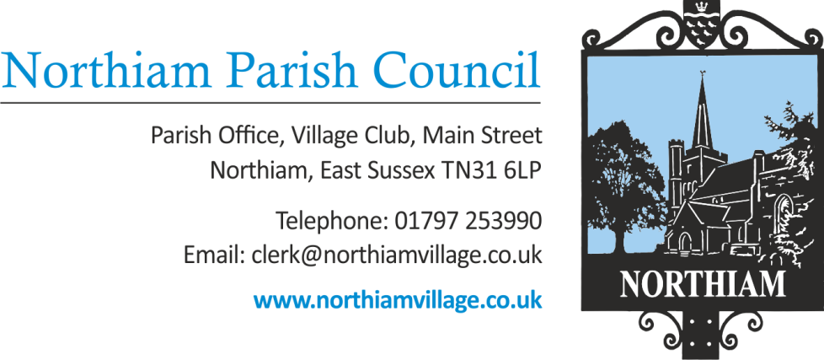

To all members of the Council, you are summoned to attend a Full Council Meeting of the Parish Council on Thursday 11th January 2024 at 19.00.

This meeting will be held at Northiam Village Hall, Main Street, Northiam

Members: Cllr Biggs, Cllr Fairbrass, Cllr Fenton, Cllr Harding, Cllr Luckett, Cllr Russell, Cllr Sargent, Cllr Schlesinger, Cllr Wadie

AGENDA

SIGNED: Nicola Ideson, Parish Clerk Date: 7th January 2024
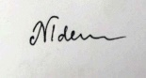
-------------------------------------------------------------------------------------------------------------------------------

 | To receive and accept Apologies for Absence
 | Chairman’s Announcements.

To adjourn the meeting to enable members of the public and Councillors to address the meeting.

This is a concessionary short session and will be limited to 15 minutes. Three minutes per person will be allowed initially and only if time permits will further comments be heard. This is a ‘for information’ session only and no action can be taken upon those items raised.

3 | To receive Declarations of Interest and Lobbying  To receive any declaration by members of personal interests in matters on the agenda, the nature of the interest and whether the member regards the interest as personal, pecuniary or prejudicial under the Code of Members Conduct.
 | Minutes to receive and approve for signature the minutes of the Council meeting held on 14th December 2023. | Appendix A
 | Minutes to receive and approve for signature the minutes of the Finance Committee meeting held on 2nd January 202$. | Appendix B
 | To receive a report from the County Councillor. | Appendix C
 | To receive reports from District Councillors. | Appendix D
 | Finance
 | To receive & approve the payment schedule for January 2024.
 | To note the bank reconciliation for November
 | To ratify the Locum Clerks time sheet (April – November 2023) this includes a payment of £2240 already approved in the October minutes. Total of £3951.63.
 | To consider the draft budget recommendation from the Finance Committee. |  | Appendix E
 | To consider the precept request 24/25 – to increase the precept by 5.1% to £113000. For a Band D Council Tax Payer this will be an increase of £5.26 a year.
 | To receive and note the interim Internal Audit. |  | Appendix F
 | To consider continuing the previous Clerk’s email supplier’s subscription for 6 months.
 | Expenditure in line with 4.1 of the Financial Regulations
 | No expenditure
 | To discuss the installation of the new perspex to the noticeboard.
 | St Francis Field
 | To consider the status of the current stables planning application due to the change in circumstances.
 | Reports from Councillors
Second Session for Public Questions
As resolved for inclusion at the July 2023 meeting, a second session for public questions or comments.
 | Resolution to exclude the Press and Public.
In accordance with section 1(2) of the Public Bodies (Admission to meetings) Act 1960 that, because of the confidential and/or sensitive nature of the business to be transacted, (may it be legal, contractual or employment issues), the press and public are instructed to withdraw.
 | Leases
 | To consider rent reviews for the bungalows.
 | HR
 | To discuss Social Media comments by individuals

