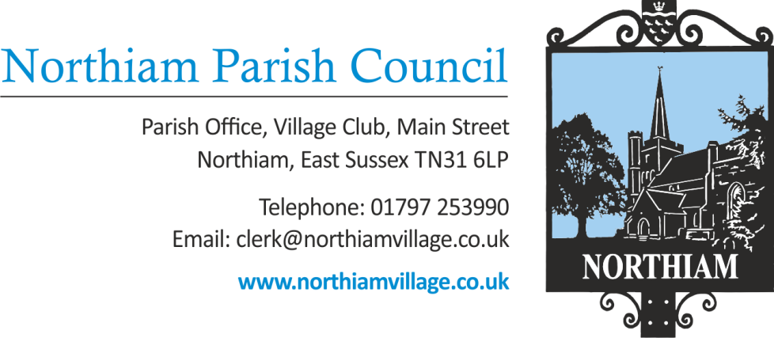

Minutes of the Full Council meeting held on Thursday 14th December 2023 held at Northiam Village Hall

Present: Cllr Fairbrass (Chair), Cllr C Biggs, Cllr Harding, Cllr Luckett, Cllr Russell, Cllr Sargent, Cllr Wadie (Vice-Chair), Cllr Fenton & Cllr Schlesinger

Also Present: Nicola Ideson Clerk, Cllr P Redstone, Cllr T Biggs (RDC), Cllr Tony Ganly (RDC) and approximately 18 members of the Public

Date: 14th December 2023

To receive and accept Apologies for Absence
No apologies were received
Chairman’s Announcements
The Chairman acknowledged the recent departure of the Stables Tenant and that any future plans for the stables need to be considered carefully and not entered into with haste. Ramifications and cost implications should not be taken lightly. A knee jerk reaction should be avoided.
To adjourn the meeting to enable members of the public and Councillors to address the meeting. This is a ‘for information’ session only and no action can be taken upon those items raised.

The meeting was closed at 19.02

Members of the public made a representations on items FC23/306 and FC23/299

This was noted by Council

The meeting was re-opened at 19.07

To receive Declarations of Interest and Lobbying
To receive any declaration by members of personal interests in matters on the agenda, the nature of the interest and whether the member regards the interest as personal, pecuniary or prejudicial under the Code of Members Conduct.
Cllr Wadie declared an interest in item FC23/307 this was noted by Council and Cllr Wadie would abstain from voting.

Minutes – It was RESOLVED that the minutes of the Full Council Meeting held on 9th November 2023 be approved as a true record of the meeting. The minutes were duly signed.
To receive report from County Councillor
Cllr Redstone’s report had been published and was circulated to Councillors prior to the meeting.

To receive report from District Councillors
The District Councillors’ report had been published and was circulated to Councillors prior to the meeting.
Finance

The payments for December 2023 were circulated and AGREED.

Payee | Amount Gross
John O’Conner | £1,082.50
NVHT | £26.00
NVHT | £100
The Down Farm | £396
HMRC | £354.56
NI Expenses | £42.76
RALC Fees | £89.00
Village Club | £213.00
Mulberry & Co | £259.92
ICO | £40.00
Gallagher | £6501.61
D & S Chestnut | £2447.24
A Wadie Expenses | £23.00
EDF | £216.31
Business Stream | £127.96
C Biggs Expenses | £23.40
Planning Portal | £160
Wellers Hedley | £600
Signs of the Times | £383.76
Staff Payments | £1612.13
Castle Water | £13.09

To consider the draft budget – The Draft budget was considered. This item was Deferred so Cllr Russell could circulate his queries prior to a Finance Committee meeting that was agreed to be scheduled for the 2nd January 2024.
To approve the opening of a Parish Council bank account with HSBC. It was RESOLVED to AGREE the opening of a bank account with HSBC.
To agree additional signatories for the Barclays bank account. It was RESOLVED to AGREE the signatories for the Barclays bank account be amended to, Councillors Biggs, Harding, Sargent and Wadie
To agree expenditure for IT support requested by the Clerk. It was RESOVED to AGREE the expenditure of £70 to Matt’ll Fix Computer Services.
Expenditure in line with 4.1 of the Financial Regulations. No Expenditure
To consider a quote to legally assess Deeds received from Greymoor Homes Ltd in relation to the Sewer Diversion at the Paddock Development. – It was RESOLVED to AGREE the expenditure of £300 to Hallett &Co. Costs to be paid for by the developer.

Governance

To agree the meeting dates for next year. The following date were AGREED in principle subject to any unforeseen circumstances Jan 11th, Feb 8th, March 7th, April 11th, May 9th, June 13th, July 11th, Sept 12th, Oct 10th , Nov 14th, Dec 12th
To consider forming an independent staffing committee – The Chairman explained that this Staffing Committee would be made up of Councillors that were not already members of the HR Committee. The Independent Staffing Committee was AGREED in principle and that the members would be Cllrs Biggs, Russell, Luckett and Fenton.
Outside Spaces
To consider the quote received for work required at the Allotments, Village Green and Goddens Gill. It was RESOLVED to AGREE the quote from DS Chestnut for £2440.
To consider forming a Playground working group. It was RESOLVED to AGREE the formation of a Playground working party in accordance with the proposal. Members were AGREED to be Cllrs Fairbrass, Fenton, Sargent and Schlesinger.
To consider a request from the ‘Plotters’ to take over responsibility for paying the allotments water bill directly. It was RESOLVED to AGREE the allotments water bill be transferred to the Plotters directly.
To consider a quote received to complete potential safety works to a tree along the footpath between Dixter Road and High Meadow.
No quotes had been received.

St Francis Field

To consider the quote for a tree safety survey at an Oak tree situated at SFF
No quotes had been received.
Updated gate license proposals
It was RESOLVED and AGREED that licenses for the gates would be unsuitable.
To consider the status of the current stables planning application due to the change in circumstances.
Deferred.

Planning applications – to consider and agree responses

RR/2023/2358/P - Coombe Cottage, Ewhurst Lane
Proposal - Demolition of existing bungalow and erection of 2no. 2-bed chalet bungalows and 1no. 4-bed bungalow. Ancillary works to include a new access and drainage system.
The Council RESOLVED to recommend refusal to this application. Detailed comments will be submitted the RDC.

RR/2023/2351/P - Fig Tree Cottage, Main Street
Proposal - Single storey infill extension with high level dormer windows.
The Council RESOLVED to support the application.

To report any external meetings with representatives of Northiam Parish Council – to allow members to ask any questions and to receive the minutes.

To report correspondence

Budget Consultation from RDC - RDC are encouraging residents to have their say on the RDC 24/25 budget plans. Closes 17th December – Councillors to comment individually.

Consultation on the East Sussex draft Local Transport Plan 4 (LTP4) Closes 25th Feb – Noted by Council
Reports from Councillors

Cllr Sargent reported on the recent Working Group meeting with the Football Club.
- Main proposal was for a New Pavilion. Points discussed include
- Location, materials, layout and potential utility means. PC representatives to investigate further.
- Estimated cost and potential grants.
- Anticipated completion date of 2025 to celebrate the Football Clubs 50th anniversary.

Cllr Biggs attended the ESALC AGM and reported on the following subjects,
- The Chairman spoke about Harassment and Hate Crime from Members of the Public and Individual Councillors against employees. Any incidents should be reported to NALC and the Police – social media is not exempt.
- Tom Warder gave a presentation on community led affordable housing.
- Steve Tilbury gave a presentation confirming that The Leveling Up & Regeneration Act was now in force. Frustrations are arising from planning procedures.
Cllr Biggs gave an update on the persistent fly-tipping at the allotments. Cllr Biggs has reported this issue on the RDC website and has spoken to Rother. Since an initial conversation in September Cllr Biggs has not had response back.
Cllr Biggs mentioned the Cemetery volunteers had asked when the works to the cemetery footpath would be looked into.

Second Session for Public Questions
As resolved for inclusion at the July 2023 meeting, a second session for public questions or comments.

The meeting was closed at 20.46

Residents made representations on items FC23/290, FC23/295 and FC23/298

This was noted by Council

The meeting was re-opened at 21.05

The Chairman moved a motion to suspend Standing Order 3x. It was RESOLVED to AGREE the suspension of Standing Order 3x and extend the length of the meeting by an estimated 20 minutes.

It was RESOLVED in accordance with section 1(2) of the Public Bodies (Admission to meetings) Act 1960 that, because of the confidential and/or sensitive nature of the business to be transacted, (may it be legal, contractual or employment issues), the press and public be instructed to withdraw.

The meeting moved into closed session at 21.12

Leases & Licences

Bowls Club Lease – It was RESOLVED to AGREE the Bowls Club Lease and for it to be executed accordingly.

Office Lease – It was RESOLVED to AGREE a contribution to the cost of the Office Lease. The expenditure of £500 to Herringtons Solicitors was APPROVED.
The meeting closed at 21.30pm

Signed…………………………………………………………………………………………
Date…………………………………………………………………………………………

