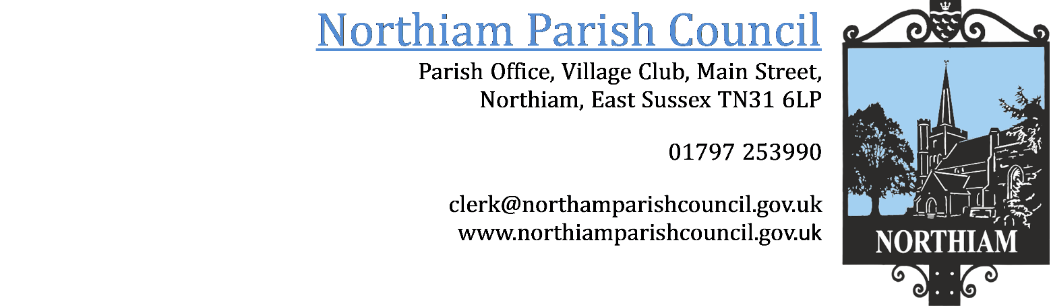

To all members of the Council, you are summoned to attend an Extraordinary Council Meeting of the Parish Council on Tuesday 9th April 2024 at 16.30.

This meeting will be held at The Jenkins Room, Northiam Village Hall, Main Street, Northiam

Members: Cllr Biggs, Cllr Fairbrass, Cllr Fenton, Cllr Harding, Cllr Luckett, Cllr Russell, Cllr Sargent, Cllr Schlesinger, Cllr Wadie

AGENDA

SIGNED: Nicola Ideson, Parish Clerk Date: 2nd April 2024
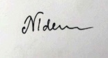
-------------------------------------------------------------------------------------------------------------------------------

To receive and accept Apologies for Absence

To receive Declarations of Interest and Lobbying

To receive any declaration by members of personal interests in matters on the agenda, the nature of the interest and whether the member regards the interest as personal, pecuniary or prejudicial under the Code of Members Conduct.

Resolution to exclude the Press and Public.
In accordance with section 1(2) of the Public Bodies (Admission to meetings) Act 1960 that, because of the confidential and/or sensitive nature of the business to be transacted, (may it be legal, contractual or employment issues), the press and public are instructed to withdraw.

Leases
To consider returning the deposit to the previous Stables Tenant.
Contractual
To consider the Management Agreement between NPC and the CIC
HR
To consider an offer from the Clerk to continue her employment as RFO only for 10 hours a week.

