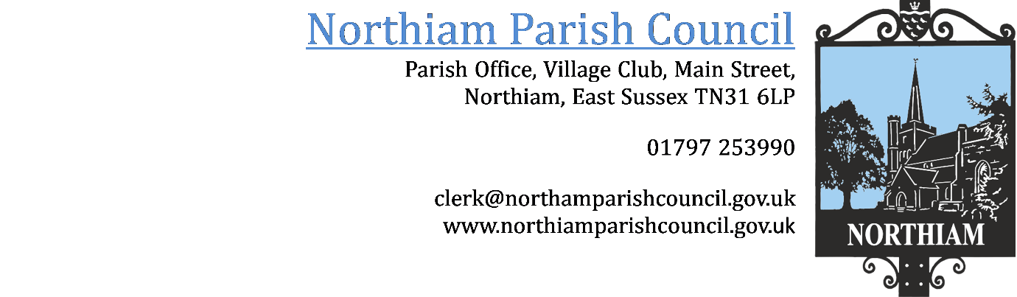
PUBLIC NOTICE
The Northiam Annual Parish Meeting will be held on 18th April at 7pm in the Village Hall.

Drinks will be available after the meeting.

